Key Chn – CT: SK, LTAFFE, AA, CMc, CB, CF, FH + Y1 PUPILS
LS: AS, AF, JH, ZC, EH, EM, OF, KGS
RA: SW, FGR, MMc, HP, NM, MH, HG, AT

AT LEAST 1 TIMED OBSERVATIONAL ASSESSMENT OF EACH KEY CHILD PER SCHOOL TERM.

Week Beginning: 23.6.2014 | PLC: Fairy Tales – Transition Unit: Once upon a Time: Which fairy tale character would you like to be and why? | Week: LC4

Key Question: What materials did the three pigs use to build their houses?
Time | Monday – |  | Tuesday – Sports Days |  |  | Wednesday |  |  |  |  | Thursday |  |  |  |  |  | Friday –
8:50 | Carpet session 1: Register. Intro chm to key question of the week. Assembly |  | Carpet session 1: Register and Wake & Shake – Take 10 |  |  | Carpet session 1: Register and Wake & Shake – Take 10 |  |  |  |  | Carpet session 1: Register and Wake & Shake – Take 10 |  |  |  |  |  | Carpet session 1: Register then Whole School Celebration Assembly
9:15 | Carpet session 2: Mathematics  Obj:SSM40-60d; ELGi  Warm Up: Estimation: Show 5 jars with between 1 and 20 cubes. Children estimate the number of cubes in each showing answers on number fans or written on whiteboards. Count out cubes. Who was near/nearest?  WALT: Measure length using a uniform unit  Show children an object and a cube. How many cubes high do you think the object will be? Children discuss with t.p and feedback their suggestions. Make a tower of cubes to measure the height of the object. Did anyone come close? Was it more or less than their estimate? Can you see something shorter/taller? Use towers of cubes to check. Can you see something about the same height? Ask children to find some other objects around the classroom to measure. Use a ‘snake’ of cubes to measure the length of some of the objects, encouraging children to make sensible estimations before measuring. |  | Adult Led Activity  Obj: Readers / observations  CT: Ind Readers/Handwriting  TA LS: : Ind Readers/Handwriting  TA RA: Cont Prov/ Outside Act |  |  | Adult Led Activity  Obj: Readers / observations  CT: Ind Readers/Handwriting  TA LS: Cont Prov/ Outside Act  TA RA: Ind Readers/Handwriting |  |  |  |  | Adult Led Activity  Obj: Readers / observations  CT: Ind Readers/Handwriting  TA LS: Cont Prov/ Outside Act  TA RA: Ind Readers/Handwriting
Adult Led Activity
CT: Ind Readers/Handwriting
TA LS: : Ind Readers/Handwriting
TA RA: Cont Prov/ Outside Act
9:15 |  |  | Children: |  |  | Children: |  |  |  |  | Children: |  |  |  |  |  | Children:
9:15 |  |  | Key Vocab:
9.45  TA LS  Setting up continuous Provision Indoor then Ind Readers  TA RA Setting up Outdoor Activities then  Ind Readers |  |  | Sports Day  Y1:  Mon: See MA Guided activity – chn to work on this independently.  Thurs: Guided: Show children a 30cm ruler. How many of these rulers do you think will fit along this table? More than 2? More than 10? Together, lay rulers along table to measure its length to the nearest whole ruler. Repeat with other distances, e.g. width of the IWB, width of a cupboard, etc. Children to say whether they think an item will be longer or shorter than previous one, and estimate the number of rulers.  Fri: Children draw 5 things that might be less than 10 cubes long, and 5 more than 10 cubes long, then measure. |  |  | Transition Day  New Starters visit pm  1:30 – 3:00 |  |  | Carpet session 2: Mathematics  Obj:SSM40-60d; ELGi  Warm Up: Shuffle a pack of 1–20 cards. Show two. Which is bigger? Children hold up number fans to answer. A pair of children make 2 towers to check.  WALT: Estimate/measure length using a uniform unit  Use a 20-bead string to measure a child’s hand span and then ask three children to work in pairs to measure a variety of different hand spans. Work together to put them in order, smallest at top and largest at bottom of sheet, or identical measurements placed alongside one another.  Children work in pairs to use the 20-bead strings to measure each other’s foot length (with socks on!). They write their names in order for their group according to foot length. Alternatively have a variety of sized feet templates available for measuring.  Show a 30cm ruler. Can you see something that is just a bit shorter than this ruler? Just a bit longer? Children use the ruler to check some suggestions by direct comparison. |  |  |  |  |  |  | Carpet session 2: Mathematics  Obj: SSM40-60d; ELGi  Warm Up: Shuffle a pack of 1–20 cards. Show two. Which is bigger? Children write number on a w/b to answer. A pair of children make 2 towers to check.  WALT: Measure and estimate by comparing with a metre stick  Take chn into the outdoor area. Pass metre sticks around. Ask chn to feel their length. Explain a metre is a length that people use all over the world to measure things. E.g When we buy a carpet we measure the length of the room in metres. How many metre sticks long do you think the race track might be? More than 2? More than 100? More than 10? Less than 10? Work together to lay metre sticks along the floor. If you run out of metre sticks, discuss the problem, and put a marker to show where 5m comes to for example, then reuse the sticks to continue measuring. The floor is 15 sticks long, that means it is 15 metres long. How wide do you think it might be? More than 15m or less? Work together to find out.
 | CT/ TA |  | CT/ TA |  |  | CT/ TA |  |  | CT/ TA |  |  |  |  |  |  | CT/ TA
10:00 | Adult Led Activity  Obj: Obj:SSM40-60d; ELGi  WALT: Order up to 3 objects by length.  Children use play dough to make between 3 and 5 worms’. They put their worms in order of length shortest to longest. They check the order and length of each using cubes with support. Photograph. |  | Adult Led Activity  Obj:  WALT:  Sports Day |  |  | Adult Led Activity  Obj:SSM40-60d; ELGi  WALT: Estimate/measure length using a uniform unit. Compare and order objects by length.  Enlarge the snake sheet to A3 size and give each child a set of snakes pre-cut. Ask chn to work independently to first estimate how many cubes they think each snake will be before using cubes to measure. Children position the snakes into their learning journey smallest to longest and record the actual length in cubes next to each snake. |  |  |  |  |  |  |  |  |  | Adult Led Activity  Obj:SSM40-60d; ELGi  WALT: Estimate/measure length using a uniform unit.  Children choose 5 things on their tables to measure using cubes, e.g. pencils, books, pencil pots, ruler, whiteboard, zip wallet etc. If necessary, add some to each table. They draw a picture of each and write the number of cubes.
10:00 | Children: LA Rainbow Fish  CT/TA/TA |  | Children: LA Rainbow Fish  CT/TA/TA |  |  | Chn: MA Hungry Caterpillars  CT/TA/TA |  |  |  | Chn: MA Elmers  CT/TA/TA |  |  |  |  |  | Children: HA Gruffalos/ Year 1’s  CT/TA/TA
10:20 | PLAYTIME
10:35 | Carpet session 3: L&S Phase 3  - Sing alphabet song p80.  - Recall j/ v/ w/ x/ y/ z/ zz/ qu/ sh/ ch/ th/ TH/ ng/ai/ ee / long oo, short oo/ oa/ ar/ or/ igh/ ur/ ow/oi/ ear, er, air, ure.  - Review high frequency words learned so far.  - Teach reading tricky words have, like, some, come p118 and decodable words it’s, just p119.  - Letters and sounds.com |  | Sports Day |  |  | Transition Day  New Starters visit pm  1:30 – 3:00 |  |  |  |  |  | Carpet session 3: L&S Phase 3  - Sing alphabet song p80.  - Review high frequency words learned so far.  - What’s in the box? p113, spot, frog, swim, drop, step, star, tree.  - Segmenting for spelling CCVC p113 plan, grip, glad, from, stop.  - Phoneme frame p116, twin, sniff, plum, gran, swim, clap, trip. |  |  | Carpet session 3: L&S Phase 3  - Sing alphabet song p80.  - Review high frequency words learned so far: we, me, be, he, she, are, see, was, will, with, my, for, too, you, this, that, they, then, them, down, her, now, all, look, are, said, so, went, from, have, like, some, come, it’s, just.  - Chn choose from available Phase 3 and 4 games/ PC/ Ind Phase 3/ 4 readers  - Spelling Quiz in 3’s
11:00 | Adult Led Activity: G. Reading/ / G. Writing/ G. Talk  Obj: R30-50e, f, i; 40-60f; ELGiiii; S40-60b, c, d; ELGii  WALT: Put the events of the story in order; talk about them using the words first, then, next.  - HA: I can put the events of the story in order and talk about them using the words first, then, next. I can rehearse and write sentences to match pictures using the words first, then, next.  - MA: I can create a story map of the story and use it to re-tell the story in sequence.  - LA: I can put three events of the story in order and talk about them.  Y1:  - Monday: Draw own story path/ 3 part story plan for The Three Little Pigs.  - Thursday: Character profile for Wolf- minimum 3-4 sentences all demarcated correctly http://www.iboard.co.uk/activity/Three-Little-Pigs-Character-Comparer-158  - Friday: Write own simple beginning/ middle and end. |  |  |  |  |  |  |  |  |  |  | Adult Led Activity: G. Reading/  G. Writing/ G. Talk  Obj:  PHONICS ASSESSMENTS  WORD CARD ASSESSMENTS  INDIVIDUAL READERS |  |  |  | Adult Led Activity: G. Reading/  G. Writing/ G. Talk  Obj:  PHONICS ASSESSMENTS  WORD CARD ASSESSMENTS  INDIVIDUAL READERS
11:00 | Children:  CT/TA/TA |  | Children: HA Gruffalo / MA Elmers/ Hungry Caterpillars/ LA Rainbow Fish  CT/TA/TA |  |  |  |  |  |  |  |  | Children:  CT/TA/TA |  |  |  | Children: CT Observations/ Identified Focus Groups from AFL
11:30  . | Carpet Session 4: CLL  Obj: W40-60g, h, i; ELGi, ii, iii, iiii  WALT: Write a profile of a character using visual and written text.  Hot-Seating: Ask Miss Smith to be one of the little pigs and to sit on a ‘special’ story chair. Model asking questions to Miss Smith in role as the pig. Who are you? How old are you? Did you build a house? How did you feel when the wolf knocked on your door/ ate your brother? Miss Smith to answer questions in role using a character voice. Invite a child to sit in the special character’s chair and take on a role. Support the children in asking the new character some questions and help children answering, as required.  Set up the character figures on the storyboard and add speech bubbles, talk briefly about the sort of voice each character might have, to enc expression and intonation. Ask chn to suggest some of the things the characters might say and model writing. (Woof! You look good to eat.) |  | Sports Day |  |  | Carpet Session 4: CLL  Obj:  WALT:  Transition Day  New Starters visit pm  1:30 – 3:00 |  |  |  |  |  | Carpet Session 4: CLL  Obj: R30-50e, f, i; 40-60f; ELGiiii; S40-60b, c, d; ELGii; W40-60g, h, i; ELGi, ii, iii, iiii  WALT: Write about the events of the story in order and talk about them using the words first, then, next.  Introduce chn to T4W Actions. Re-tell the story using PPT and T4W. Refer to story map from LC3.  Remind chn of the shared story and show them the paper divided into 3 sections on the teaching board. Explain that you are going to draw what happened at the beginning of the story in the first box and ask for suggestions as to what could be drawn. Model including as much detail as possible to support the chn doing this independently in the writing area during child initiated activities.  Then talk about the ending of the story – again modelling as much detail as possible.  Point out that one section remains blank and ask the chn to suggest what to put in this space while I draw it. Recap on what has been drawn to structure the story into a beginning middle and end.  Remind chn of our target words for sequencing and re-telling stories (First… Then… Next… Soon… Suddenly… After that… Finally… At last.) Which words would be a good story opener for each section. How do fairy tales typically start/ end?  Model writing a simple beginning, middle and ending to create own version of TTLP story using ideas suggested by the children. Ensure that modelled writing includes the refrain used by both the pigs and wolf.
11:30  . | CT/TA |  | CT/TA |  |  | CT/TA |  |  |  |  |  | CT/TA |  |  |  | CT/TA
11:50-12:00 | PSED/ Singing:  Handwashing & Lunchtime
1:00 | Carpet Session 5: Register and  Wake & Shake – Take 10 |  | Carpet Session 5: Register and  Wake & Shake – Take 10 |  |  | Carpet Session 5: Register and  Wake & Shake – Take 10 |  |  |  |  | Carpet Session 5: Register and  Wake & Shake – Take 10 |  |  |  |  |  | Carpet Session 5: Register and  Wake & Shake – Take 10
1:15 | Carpet Session 6:  Obj: (EMM30-50d, e, f; 40-60b ELGi; BI30-50c, e, f; ELGii links with T40-60a, b;ELGi, ii)  WALT: Explore and talk about different textures.  CT AIA: Discuss different textures. What does texture mean? Investigate and discuss how they look/feel. Take this outside if possible. Or hand around a variety of rough textured surfaces, e.g. brick, corrugated card, hessian fabric, wood, concrete, tree bark, leather, etc and explain that we shall make rubbings using these materials. Model - Ask chn what kind of pattern they would expect to appear. Model using side of crayon. Do rubbings of diff textures and use to create individual collages. How can we draw diff textures using just pencils? Experiment with dots, lines and shading to create different effects |  | Sports Day |  |  | Transition Day  New Starters visit pm 1:30 – 3:00  Name Buttons People  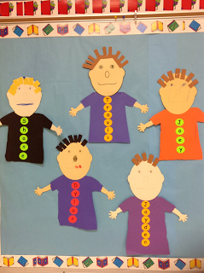  Numbers and counting Activity  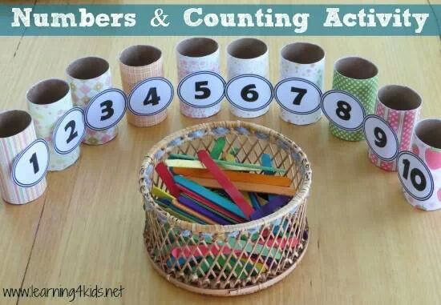  Concentric Shape Pictures – Baseline assessment 2D shapes  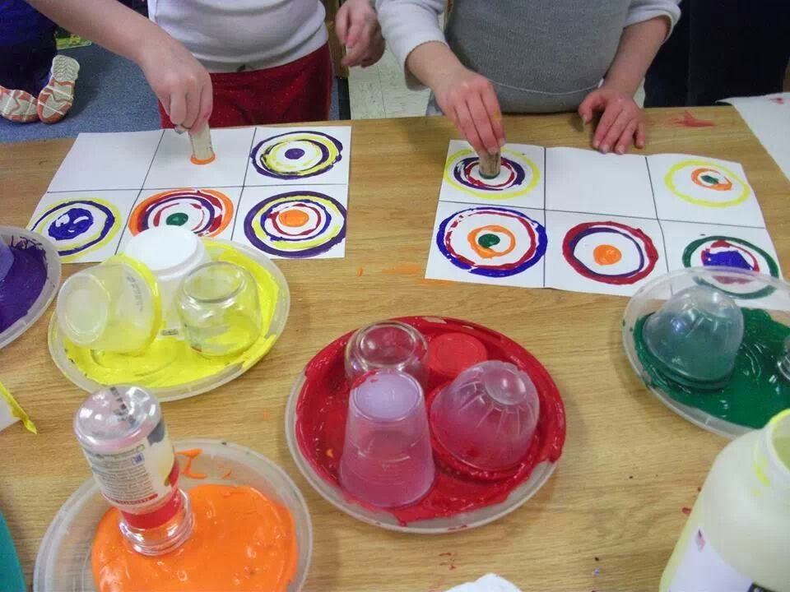  See also continuous Provision Plans and Outdoor Play |  |  |  |  | Physical Development : FSp  Obj: (MH30-50a, d, f; 40-60a, c, d, e, g, h; ELGi, ii, iii; HSc30-50f; 40-60c, d, e, f; ELGi, ii; links with C&L U30-50c; 40-60a, d; PSED SCSA30-50d; 40-60b; ELGi, iii)  See separate planning. LCP Athletics 1– Running Session 3 and 4:  WALT:  - Choose skills and equipment to help us meet set challenges. Remember, repeat and link combinations of actions.  - Use our bodies and a variety of equipment with greater control and coordination.  - Recognise and describe what our bodies feel like during different types of activity. Watch, copy and describe what we and others have done.  Resources: playing field, playground  or hall, cones, hoops, skipping ropes, stopwatches, Flipbook page 19: Running, CD-ROM: Running  TA: Ind Readers/ Word Games |  |  |  |  |  | Carpet session 6: L&S Phase 3  - Give the sound when shown any Phase 2 and 3 grapheme.  - Find any Phase 2 or 3 grapheme, from a display, when given the sound.  - Be able to blend and read words containing adjacent consonants.  - Be able to segment and spell words containing adjacent consonants.  - Be able to read the tricky words some, one, said, come, do, so, were, when, have, there, out, like, little, what.  - Be able to spell the tricky words he, she, we, me, be, was, my, you, her, they, all, are.  - Write each letter, usually correctly.
1:45 | Adult Led Activity  Obj: (EMM30-50d, e, f; 40-60b ELGi; BI30-50c, e, f; ELGii links with T40-60a, b;ELGi, ii)  Resources: Create a ppt – bricks and Klee, Paint, Pastels, ICT paint  Paper  WALT: look at how artists have used colour, shapes and lines. Create own artwork using colours to create an effect  TA AIA: Show children pics of bricks and discuss patterns. Look at the lines. Show Klee pictures – what do you notice? Discuss how Klee has used colour and shape to create buildings. Create own Klee pictures using paint/pastels and ICT.  LA/MA chn to be given an outline to fill in using colour. Alternatively use house on 2Paint Project on Purple Mash  CT: Observing/ Ind Readers |  |  |  |  |  |  |  |  |  | See MTP Spring 4 RE/ SEAL Plans:  Obj: (MR 30-50c,d; 40-60a; ELG; SCSA 40-60b; MFB ELG work as part of a group/class – links with CLL LA 40-60a)  TA AIA: Remind the children circle time skills. Recap on what it means to be “going for a goal”. WALT: Recognise what is fair. Know how to make someone feel better.  - Pass the smile – around the circle. Turn to the person on your right and smile. They smile back and then turn and smile to the person on their right, and so on… Repeat passing the smile to the person on your left.  - Greetings your majesty – a child sits with their back to the circle. Each child takes it in turn to walk up, bow and say ‘Greetings your majesty’. The King/Queen has to guess who it is or loses their throne.  - Discuss the story of Cinderella with the children – Use the Cinderella props from the drama bag to establish main characters, setting, main events etc. Read story if necessary to recap.  - Discuss which jobs Cinderella might have done for her stepmother and stepsisters at the beginning of the story and make a list (e.g. scrubbing the floor, sweeping, cleaning the oven, dusting, peeling potatoes, cleaning windows, making beds etc. Teacher mimes a job from the list and children guess which it is. Choose a child to mime a job from the list and the class guess.  - See also PSED MTP
2:05 | Whole School Assembly
2:20 | PLAYTIME
2:30 | Adult Led Activity  Obj:  TA: Continue as before break  CT: Observing/ Ind Readers |  | Adult Led Activity  Obj:  TA: Continue as before break  CT: Observing/ Ind Readers |  |  | Adult Led Activity  Obj:  CT: Continue as before break  TA AIA: Observing/ Ind Readers. |  |  |  |  | EA& Music: FS  Obj: See MTP  CTAIA: The Storm. WALT: To compose a piece of music called ‘The Storm’ AIA: Use percussion instruments to represent the sounds in a storm. Record on a grid using symbols TA READERS |  |  |  |  |  | Golden Time  FILM  CLUB
3:00 – 3:20 | Story and Hometime: Look at the opening words in fairy stories – do they always begin with ‘Once upon a time’? Do they always end with ‘ And they lived happily ever after’? Each day read an alternative version/ fairy tale selected by chn. (R30-50f, i; ELGi, ii, iii, iiii; S40-60a, d; ELGii)
Continuous/ Enhanced Provision – Classroom/ Central Learning Environment

http://www.earlylearninghq.org.uk/stories/three-little-pigs/ ; http://uk.pinterest.com/candy7470/the-three-little-pigs/
Malleable Act: |  | EYFS: Can you follow the instructions on the playdough mats?  Y1: Can you use the playdough to make the different characters in our story? Which tools will you use? Use malleable materials e.g. playdough/clay for rolling and cutting; encourage chn to use a variety of tools to add more detailed features.
Sand Act/ Tuff Spot: |  | EYFS: Building site, gravel, bricks, vehicles, play people/ cut out characters from TTLPigs, Construction vehicles in the sand. Can you use the storyboard and cut out characters to retell the story? Help chn to recreate an imaginary small world area to retell the story journey took by the Three Little Pigs.  Y1: Enc chn to make recordings of their stories using either the tuff cameras/ microphones/ iPads. Can you write your story on the writing frames provided?
Water Act: |  | EYFS/Y1: Bear counters and green shredded paper/ porridge oats  Can you help me sort the different bears into groups and find out which groups have the least and most? How could we sort the bears? How will we record our work to compare groups? |  |  |  |  |  |  |  |  |  |  |  | Sand and water to make pretend cement. Can you describe how sand changes when water is added? Add trucks, rakes, combs and lollipop sticks.  Enhance: Using fairy liquid mixed in to explore with hands first then add different containers, spoons, sticks scoops etc.
Number World Act: |  | EYFS/Y1: What will we need in the class shop to turn it into a Baker’s Shop role play area? Model and play alongside the chn as they use money to pay and give change for items bought in the shop. |  |  |  |  |  | Model and play alongside children using Cuisenaire rods to build a house for the three little pigs to help support understanding of addition and rapid recall of addition facts to 10. AIA: MA/ LA: Have the children use the rods to make the number sentences listed along the side on the page stacking the rods to "build" the house. HA: Chn to investigate which rods can be used to make the house and record number sentences to show what they have done. (N40-60k, n, o; ELGi, ii, iii; SSM40-60f; ELGii)  http://www.makinglearningfun.com/themepages/3PigsBrickHouseCuisenaireRodAddition.htm; http://www.makinglearningfun.com/themepages/3PigsRollandColor.htm
  Music/ Listening Act: |  | Can you use a variety of instruments and actions to create your own Three Little Pigs sound story? (EMM30-50d, e, f; 40-60a, b; ELGi; links with T40-60a, b;ELGi, ii) |  | EYFS/Y1: Can you learn and remember a variety of songs about different fairy tales using actions and simple percussion instruments? E.g. The Gingerbread Man song, ‘When Goldilocks went to the house of the bears.…’  http://www.disney.co.uk/disney-songs/ Sing along songs from the Disney films,  http://www.songsforteaching.com/fairytales/index.htm When Goldilocks went to the house of the bears.  http://www.mrsjonesroom.com/songs/gingerbreadman.html , http://www.youtube.com/watch?v=Q5aUAxK1ec8 /  http://www.canteach.ca/elementary/songspoems95.html
Writing Act: |  | EYFS: Can you draw pictures of characters from the story; label underneath with their name and add a speech bubble to show what they might say?  Y1: Can you design a new home for the Pigs? How would you describe your home for an estate agent’s brochure about homes? |  |  |  |  |  | EYFS: Can you sequence your own pictures from the story and retell it using the camera/ microphone?  Y1: Can you draw your own story map to show the journey of the story characters? Can you draw your own pictures to show the beginning, middle and ending of the different stories we have been learning about?
Construct  Act: |  | EYFS/Y1: Problem solving: What construction resources will you use to make a house as strong as the brick house? (Test using a hairdryer or fan)  Y1: Encourage chn to design and plan what they will need for their models before starting.
Creative Act: |  | EYFS: Provide children with a basic drawing of three houses on an A3 piece of paper.  Can you use the collage materials to create the three houses from the story of The Three Little Pigs? Demonstrate how to use the glue and the collage material to the children before leaving them to work independently. (EMM30-50j, k, l, m; 40-60c, d, e, f, g, h, i, j; ELGii; BI30-50j; 40-60a, c; ELGi, ii)  Y1: Create own collages without basic drawings for support. |  |  |  |  |  |  |  |  |  |  | Encourage and support the children to create some Huff and Puff" art. Model how to put drops of watery paint on paper then blow it with straws. Discuss what patterns and shapes the children can make. (EMM30-50g, m; 40-60c, e, h; ELGii; BI30-50j; 40-60c; ELGi, ii)
  ICT: |  | EYFS: Can you make and print a scene from the story of the Three Little Pigs? Can you make up a new scene? http://www.iboard.co.uk/activities/page/8/subject/english/years/4-7/path/narrative-texts  Y1: Which fairy tale activity will you choose to do on Purple Mash?
Book Act/ Puppet theatre: |  | Alternative versions of The Three Little Pigs to be added to the Reading Area |  |  | The Three Little Pigs sequencing cards to be added to the Reading Area |  | The Three Little Pigs masks/ puppets to be added to the Reading Area |  |  |  |  |  | Read and then talk about the story with the children: Who are the characters? What does each character do? Why did the pigs build their different houses? Why did the wolf want to blow them down? How did he feel when he had blown down the first house? Where did the pigs live before? Does the wolf have a brother or sister? Role play the story using masks, taking it in turns for children to be different characters. (LA30-50b, ELGii; S40-60c)
Sml World/ Tuff spot Act: |  | EYFS/Y1: Can you re-tell a Fairy tale that you know using the small world toys.  Set up castle small world area and fairy tale mat. Ensure that a large selection of books are available for children to refer to.
Home Corner/ Role Play |  | The Three Bears Wood and Home Corner: Three Bears Cottage. Help chn to adapt the Gruffalo home corner Café into the cottage belonging to the Three Bears, where they can play freely and recreate scenes from the story. Focus on developing the children’s understanding of number and size. E.g. Place a table in the cottage and ask the children to find three sets each of large, medium and small spoons, plastic dishes, plastic cups, chairs, beds and teddy bears, and a fair-haired doll to represent Goldilocks. Provide other play items such as a role-play microwave or cooker for making pretend porridge, dressing-up clothes such as a waistcoat for Father Bear, a necklace for Mother Bear and a bib for Baby Bear. Encourage the children to think of other activities, not mentioned in the story, that the bears may be involved in, such as going shopping, talking about the weather, discussing what they want to eat, bedtime routines and so on, to help them broaden their play activities in the area. Leave the story of Goldilocks and the Three Bears in the role-play cottage for the children to refer to. (BI30-50g, i, j; 40-60e, f; ELGii; EMM ELGii)  Provide some opportunities for free play based on the story, for example, in the home corner set out as a kitchen, or against a wall display showing fields, a path and a riverbank. Take the action outside by marking out a stream in the outdoor play area. Invite the children to be one of the characters from the story, for example, the Gingerbread Man running away, or one of the characters chasing him. Encourage them to think about how their character might move as they act out the chase. Develop this into a circle game. Play it along similar lines to the traditional ‘Duck, Duck, Goose’. As the children sit in a circle, walk around the edge and choose a child to be the baker. Then tap another child on the shoulder and say, ‘Run, run, run, as fast as you can!’. Both of the children should now get up and run around the circle, and the baker tries to catch the gingerbread man before he gets back to his place again. (BI30-50g, i, j; 40-60e, f; ELGii; EMM ELGii)
Outdoor Act:  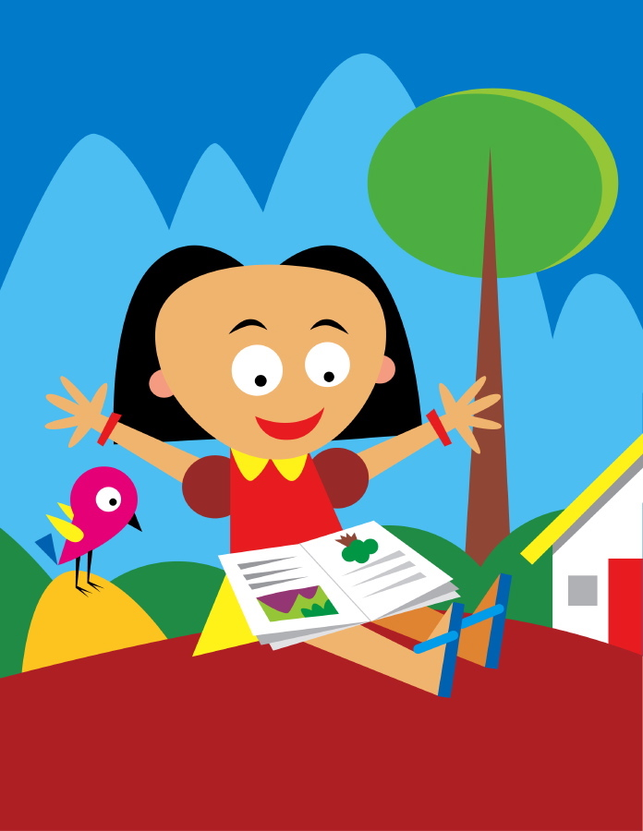 |  | See Outdoor Play Plans: Week 3  Ensure that the planned indoor provision is reflected in the outdoor provision. Both prime and specific areas need to be explored.  - Construct a house for the pigs in the outdoor area. AIA: Use a wide variety of building equipment to encourage children to practise making structures that will stand upright and have space inside where a character could ‘live’. Use hands and fingers to push components together to create a stronger support. Supply children with a range of junk modelling resources suitable for their age. Demonstrate ways to assemble and fix together resources, such as by cutting, slotting and sticking. Encourage children to use scissors correctly to segment materials. Using coloured dough, rolling pins and hands, manipulate the dough to make shapes to represent the three little pigs and the wolf. Use modelling tools to add detail. Can the children draw a background for their animals or create some paper furniture for their houses? Collect long, thin twigs to make a simple weaving frame with sufficient space for small fingers to manipulate twigs or strips of material through to create a wall for a house. Secure panels together and experiment with it standing up. Can children huff and puff to blow it down? Using suitable climbing apparatus, indoors or outdoors, role play the story of ‘The Three Little Pigs’. Use large bricks to create walls and practise being the wolf ‘looking down the chimney’. Play chasing games as the pigs flee from the wolf. Try bundling and tying straw to make a straw house – this provides great opportunities for children to work together, too, securing the bundle for another to tie. (MH30-50h; 40-60f, g; ELGiii links with EMM30-50j, k, l, m; 40-60c, d, e, f, g, h, i, j; ELGii) See MTP for suggested resources.  - Take the chn on a materials hunt in the outdoor environment to learn about building materials. Working in pairs the children used clipboards to record their findings.

